1. **Robotic Arm**

|  |  |  |  |  |  |
| --- | --- | --- | --- | --- | --- |
| **S/N** | **Component** | **Quantity** | **Need to order (Yes/No/Don’t Know)** | **Budget** | **Confirmed (Yes/No)** |
| 1 | Servo Motor for end-effector | 1-2 | Yes | Still sourcing all | Yes |
| 2 | Linear Actuator | 2 | Yes |  | Yes |
| 3 | Stepper Motor | 1 | Yes |  | Yes |
| 4 | *Resistors* | 6-8 | Yes |  | No |
| 5 | *Inductors* | 6-8 | Yes |  | Yes |
| 6 | *Motor for End Effector (Claw, hex bit, digger / hand)* | 3 | Yes |  | No |
| 7 | Planetary Gear | 1 | Yes |  | Yes |
| 8 | Gear Reducers | 1-2 | Yes |  | Yes |

1. **Comms**

|  |  |  |  |  |  |
| --- | --- | --- | --- | --- | --- |
| **S/N** | **Component** | **Quantity** | **Need to order (Yes/No/Don’t Know)** | **Budget (S$)** | **Confirmed (Yes/No)** |
| 1 | AirMAX Antenna 2.4GHz Wifi | 1 | No | 290 | Yes |
| 2 | HyperLink Wireless Brand 2.4 GHz 12 dBi Omnidirectional Antenna (Model HG2412UP-NF) | 1 | No | 296 | Yes |
| 3. | Ubiquiti 2.4GHz Rocket MIMO, airMAX (Rocket M2) | 2 | Yes (1)  ordered 1 | 165  165 | Yes |

1. **Chassis + Science**

|  |  |  |  |  |  |
| --- | --- | --- | --- | --- | --- |
| **S/N** | **Component** | **Quantity** | **Need to order (Yes/No/Don’t Know)** | **Budget** | **Confirmed (Yes/No)** |
| 1 | STEPPERONLINE 3PCS Nema 17 Stepper Motor 1.5A 12V 45Ncm (63.74oz.in) 4-Lead 39mm Body W/ 1m Cable and Connector for DIY CNC/ 3D Printer/Extruder **(for SCU)** | 4 | Yes  <https://www.amazon.sg/gp/product/B07LCK19D5/ref=ox_sc_act_title_1?smid=ARPIJN329XQ0D&th=1>  (Ordered already) | 4 x S$33.28 = **S$133.12** | Yes |
| 2 | Laser for Spectrophotometer | 1 | **Yes** (previous Science team lead hasn’t given an update, currently don’t have purchase link yet) |  | Yes |
| 3 | Ultrasonic Module HC-SR04 Distance Measuring Transducer Sensor 5V  **(for SCU, helps with maintaining scoop at a specific desirable height)** | 4 | Yes  <https://shopee.sg/Ultrasonic-Module-HC-SR04-Distance-Measuring-Transducer-Sensor-5V-i.189216177.4502022091> | 4 x S$1.56 =  **S$6.24** | Yes |
| 4 | Servo motor for sampling scoop: STANDARD SERVO - TOWERPRO SG-5010 **(for SCU)** | 2 | Yes  <http://www.3egadgets.com/robotics/101-standard-servo-towerpro-sg-5010.html> | 2 x S$17.50 =  **S$35.00** | Yes |
| 5 | Sample Analysis Unit SAU: Nema 17 Stepper Motor 12V 1.5A (26Ncm) | 1 | No | - | Yes |
| 6 | Sample Analysis Unit SAU: CCD42-10 Back Illuminated High Performance AIMO CCD Sensor | 1 | **Yes (no purchase link found yet)** | **???????** | Yes |
| 7 | Sample Processing Unit SPU: Nema 17 Stepper Motor 12V 1.5A (26Ncm) | 1 | No | - | Yes |
| 8 | Sample Processing Unit SPU: AC 220V 60W-100W Ultrasonic Cleaner Power Driver Board With 2Pcs 50W 40KHZ Transducers | 1 | Yes  <https://www.aliexpress.com/item/32879729869.html> | **S$57,65** | Yes |
| 9 | Atmosphere Sensor Suite ATMOS: Arduino Uno R3  Water Sensor Soil Moisture | 1 | No | - | Yes |
| 10 | Atmosphere Sensor Suite ATMOS: Soil Hygrometer Humidity Detection Module Moisture | 2 (according to URC 2021 Budget on Microsoft Teams) | Yes  [Soil Hygrometer Humidity Detection Module Moisture Water Sensor Soil Moisture | Shopee Singapore](https://shopee.sg/product/189216177/5910095838?smtt=0.198009852-1615124334.9) | **S$2.84** | Yes |
| 11 | Atmosphere Sensor Suite ATMOS: DHT11 DHT-11 Temperature and Relative Humidity Sensor Module | 1 | No | - | Yes |
| 12 | L298N Drivers | 7 (for SEU, SAU, and SCU) | No | - | Yes |
| 13 | 80 mm PC CPU Case Fans DC 12V Computer Fan 80mm 3.15 inch 2 Pin XH 2.54 8025 High Performance Cooling Fan 3000RPM 2-Pack **(for SCU, to clear up soil and rock samples from scoop)** | 1 | Yes  <https://www.amazon.sg/Computer-Performance-Cooling-3000RPM-2-Pack/dp/B07R52RY3P?th=1>  (Ordered already) | **S$22.15** | Yes |
| 14 | Raspberry Pi Camera V2 Camera Module **(for real-time monitoring of science package, esp. SCU to help with picking up sample)** | 1 | Yes  <http://sun-light.com.sg/index.php?route=product/product&product_id=3422> | **S$ 44.50** | Yes |

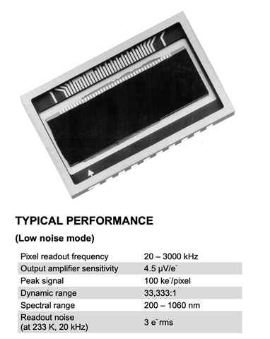

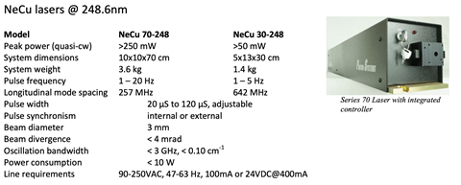

1. **Mobility**

|  |  |  |  |  |  |
| --- | --- | --- | --- | --- | --- |
| **S/N** | **Component** | **Quantity** | **Need to order (Yes/No/Don’t Know)** | **Budget (S$)** | **Confirmed (Yes/No)** |
| 1 | Alien Power Systems Motors | 6 | No |  | Yes |
| 2 | Flipsky FSESC Motor Controllers | 6 | Yes (Only 1) | S$182.50 | Yes |
| 3 | DC-DC Converters | 6 | No |  | Yes |
| 4 | Micro-controller – Arduino Nano | 1 | Yes | S$21.30 | Yes |

1. Navigation

|  |  |  |  |  |  |
| --- | --- | --- | --- | --- | --- |
| **S/N** | **Component** | **Quantity** | **Need to order (Yes/No/Don’t Know)** | **Budget (S$)** | **Confirmed (Yes/No)** |
| 1 | Intel Realsense Depth Camera D435 | 2 | No | S$435  S$435 | Yes |
| 2 | DP0501 RTK GNSS (GPS module) | 1 | No | $450 | Yes |
| 3 | NVIDIA Jetson Nano (Processor) | 1 | Yes | S$500 | Yes |
| 4 | MPU-9250 (IMU) | 1 | Yes | S$12 | Yes |